Hitachi Electronic Products (M) Sdn. Bhd.
Malaysia E-invoicing

Technical Specification – E-invoicing Program
TS_INT-001
Version 1.0

Table of Contents
Table of Contents 2
Document Control 3
Revision History 4
1 Request Overview 5
1.1. General Information 5
2 Technical Architecture 6
2.1 Technical Elements 6
2.2 Program Details 6
2.3 Screen Details 6
2.4 Technical Flow 10
2.4.1 Search help 11
2.4.2 Select data for processing 20
2.4.3 Function 39
2.5 Technical Unit Test 54

Document Control
<Client >Team Lead
Functional Analyst | Lan Huynh
Technical Reviewer | Dung DANG
Technical Developer | Thanh Dinh
Specification Approval Date
Functional Unit Test Approval

Revision History
Revision Comments | Revised By | Revision Date | Version
Initial version | Thanh Dinh | 14-March-2024 | 1.0

Request Overview

General Information
Request Type | R
Development ID (RICEF #) | ZFI116
Request Title | E-Invoice Item Report
Description | E-Invoice Item Report
Business Process | Business Process
Business Priority | ( ) Critical, (X ) High, ( ) Medium, ( ) Low
SAP System Component(s) | MM, SD, FI – Interface
SAP System Module(s) | MM, SD, FI
Is there an alternative in the standard system? | ( ) Yes, (X) No
Description of alternative | NA
Reasons why alternative is not acceptable: | ( ) Performance problems, ( ) Complexity, ( ) Other  Complexity in master data maintenance.

Technical Architecture

Technical Elements
Type | Name | Dev. Class | Description
Include | ZFIKRS116_V1_TOP |  | Data declaration
Include | ZFIKRS116_V1_SEL |  | Selection screen
Include | ZFIKRS116_V1_CD |  | Classes definition
Include | ZFIKRS116_V1_CI |  | Classes implementation
Include | ZFIKRS116_V1_O01 |  | PBO
Include | ZFIKRS116_V1_I01 |  | PAI
Include | ZFIKRS116_V1_F01 |  | Functions
Program | ZFIKRS116_V1
Domain
Data element
Data element
Table
Table
Structure | ZST_EINV_ALV |  | Structure for eInvoice ALV
Structure | ZST_EINV_ALV_DETAIL |  | Structure for ALV Detail
Structure | ZST_EINV_ALV1 |  | Structure for eInvoice ALV
Transaction | ZFI116

Program Details
Tcode: ZFI116

Screen Details
2.3.1 Selection Screen of Customer
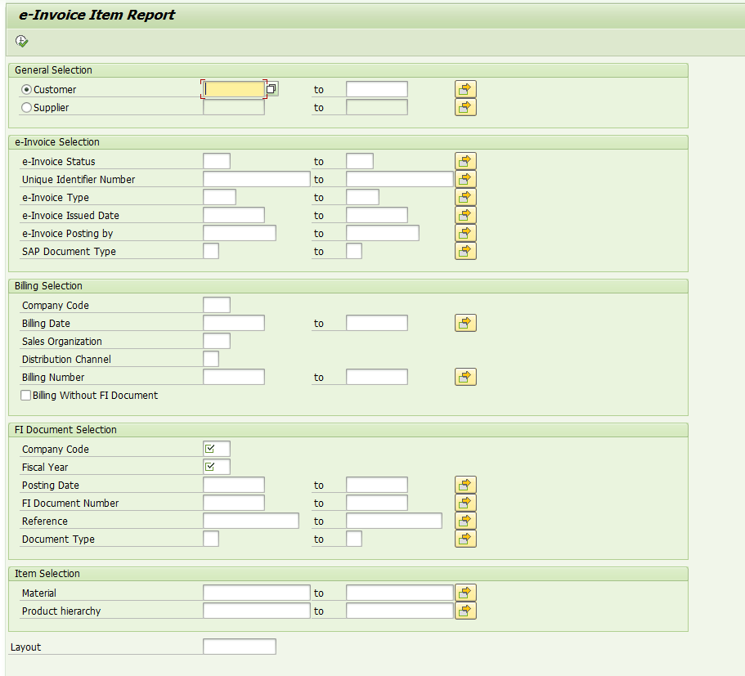

Name | Type | Description
S_KUNAG | VBRK-KUNAG | Customer
S_EISTA | ZFIEINV1-EISTA | e-Invoice Status
S_UINUM | ZFIEINV1-UINUM | Unique Identifier Number
S_INTYP | ZFIEINV1-INTYP | e-Invoice Type
S_ISDAT | ZFIEINV1-ISDAT | e-Invoice Issued Date
S_ISPIC | ZFIEINV1- ISPIC | e-Invoice Posting by
S_SDOCT | BKPF-BLART | SAP Document Type
P_CCODE | BKPF- BUKRS | Company Code
S_FKDAT | VBRK- FKDAT | Billing Date
S_VKORG | VBRK- VKORG | Sales Organization
S_VTWEG | VBRK- VTWEG | Distribution Channel
S_BILLNO | VBRK-VBELN | Billing Number
P_BILL | Check box | Billing Without FI Document
P_BUKRS | BKPF- BUKRS | Company Code
S_GJAHR | BKPF- GJAHR | Fiscal Year
S_BUDAT | BKPF- BUDAT | Posting Date
S_FINO | BKPF- BELNR | FI Document Number
S_REFDOC | BKPF- XBLNR | Reference
S_BLART | BKPF-BLART | Document Type
P_VARI | DISVARIANT- VARIANT | Layout

2.3.2. Selection screen of Supplier
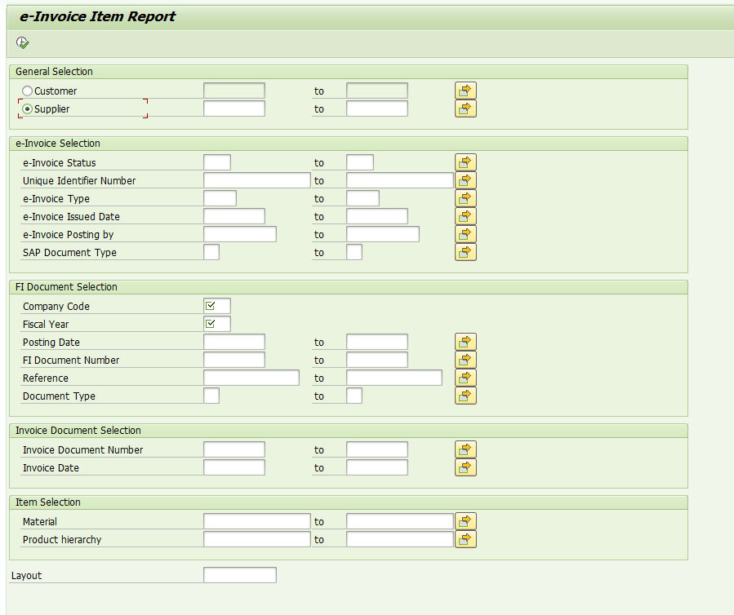

Name | Type | Description
S_LIFNR | BSEG-LIFNR | Supplier
S_EISTA | ZFIEINV1-EISTA | e-Invoice Status
S_UINUM | ZFIEINV1-UINUM | Unique Identifier Number
S_INTYP | ZFIEINV1-INTYP | e-Invoice Type
S_ISDAT | ZFIEINV1-ISDAT | e-Invoice Issued Date
S_ISPIC | ZFIEINV1- ISPIC | e-Invoice Posting by
S_SDOCT | BKPF-BLART | SAP Document Type
P_BUKRS | BKPF- BUKRS | Company Code
S_GJAHR | BKPF- GJAHR | Fiscal Year
S_BUDAT | BKPF- BUDAT | Posting Date
S_FINO | BKPF- BELNR | FI Document Number
S_REFDOC | BKPF- XBLNR | Reference
S_BLART | BKPF-BLART | Document Type
S_INVDOC | RBKP-BELNR | Invoice Document Number
S_INVDAT | RBKP-BLDAT | Invoice Date
P_VARI | DISVARIANT- VARIANT | Layout

Technical Flow
Start

Select data

ALV

Search help
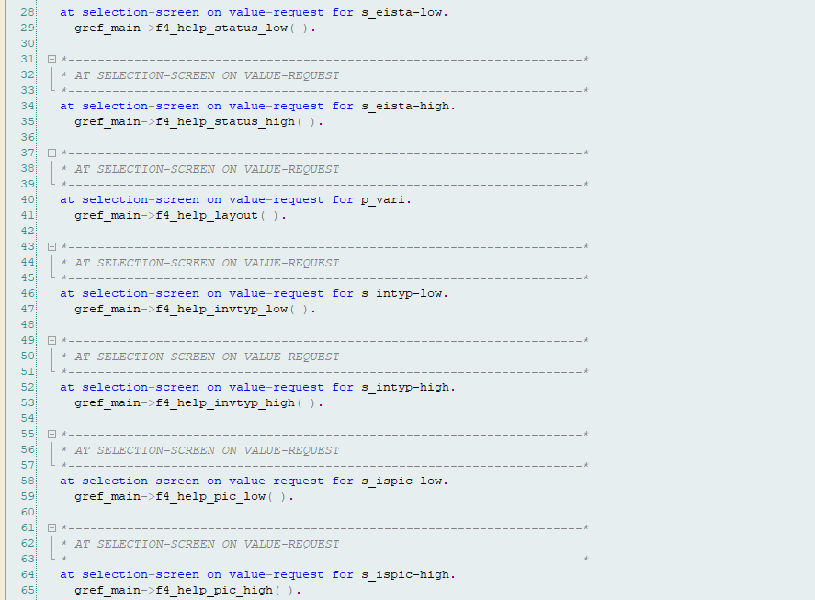
- Define and Implement.

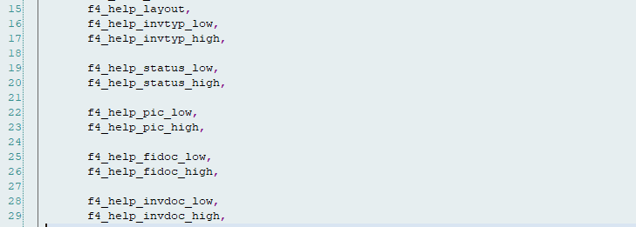

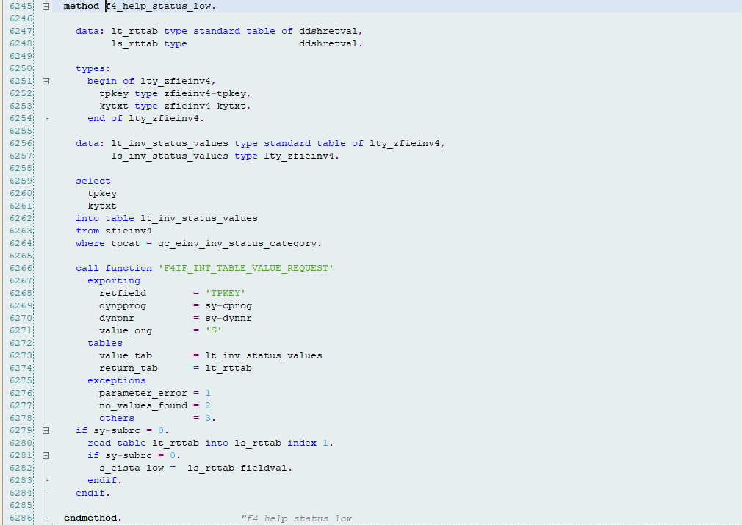
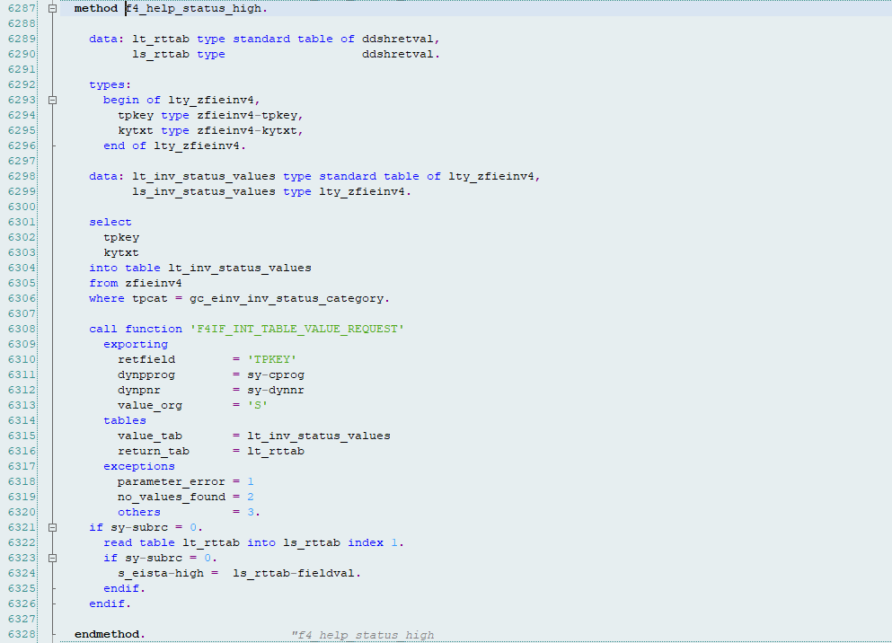
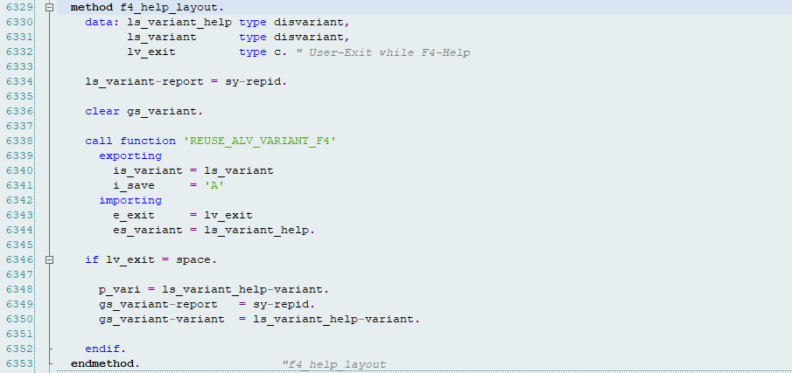
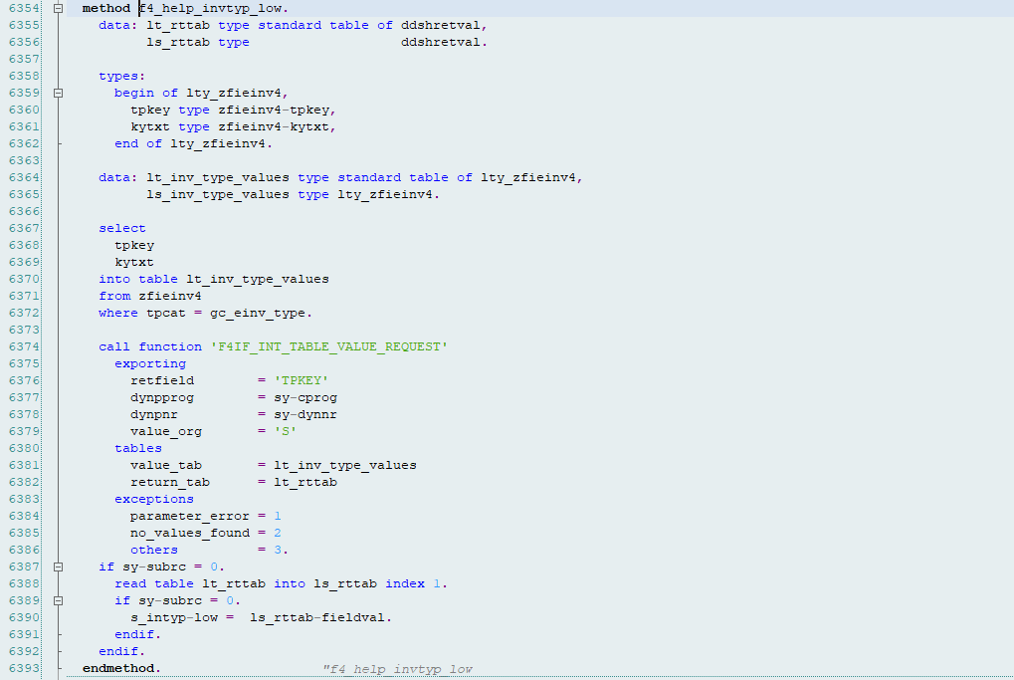
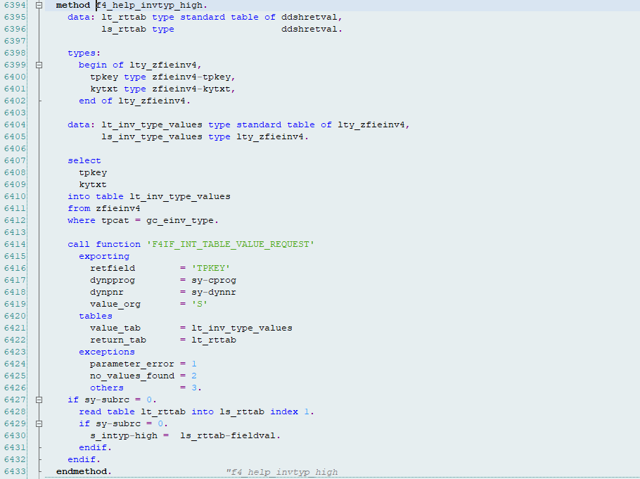
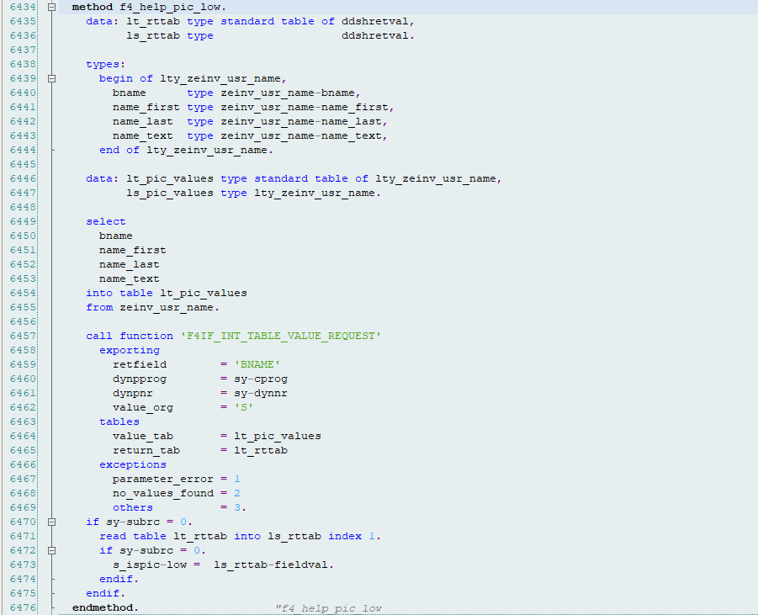

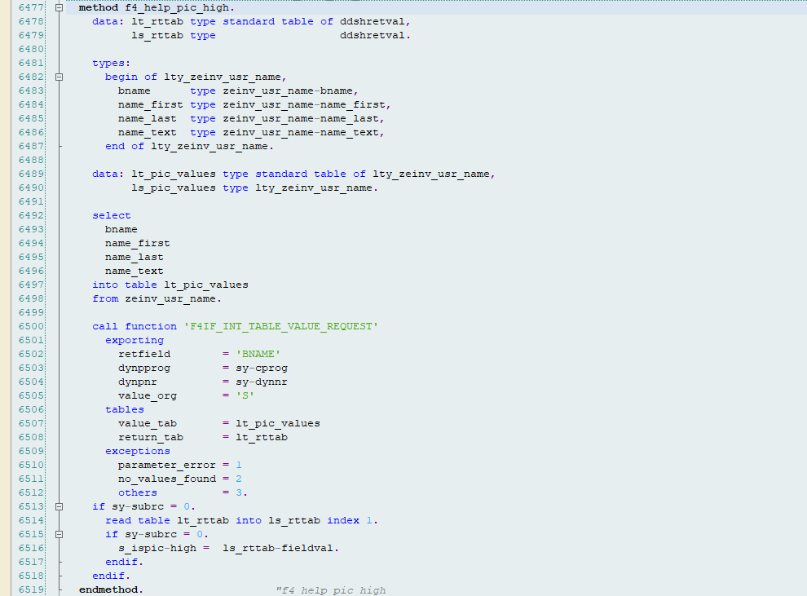

Select data for processing
2.4.2.1 Select data for Supplier
Method : GET_SUPP_DATA
Code line: from 606 to 3003.
Select data from BKPF, BSEG, ZFIEINV1, ZMM_CNDN_NO, RBKP, BSET, RSEG, KONP, EKKO, MARC, LFA1, VBPA, ADRC.
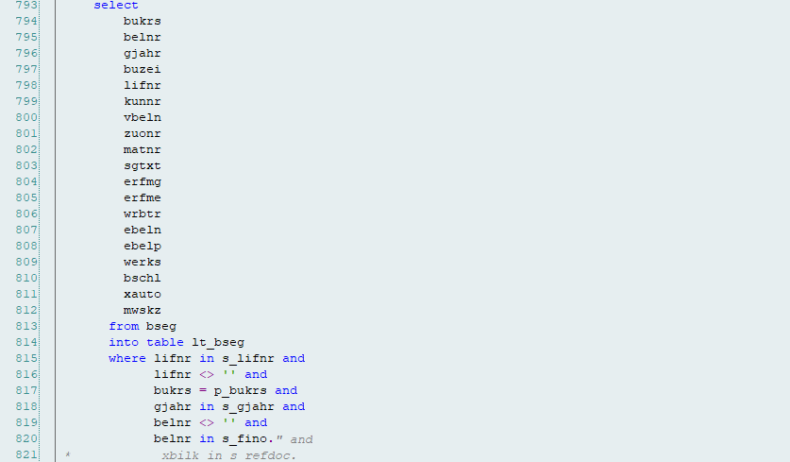
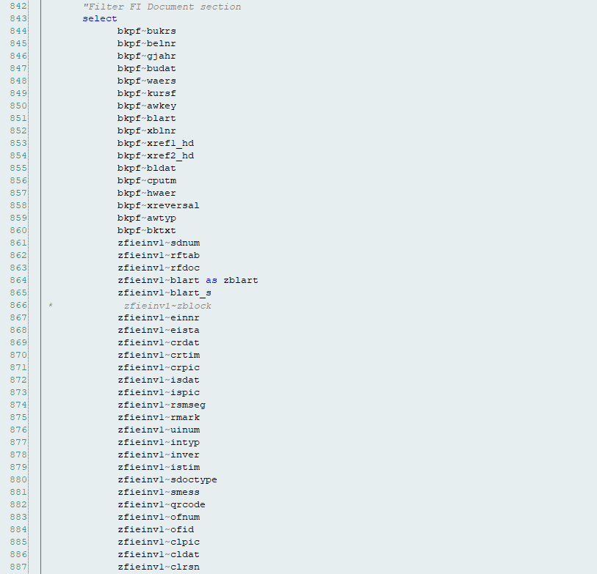
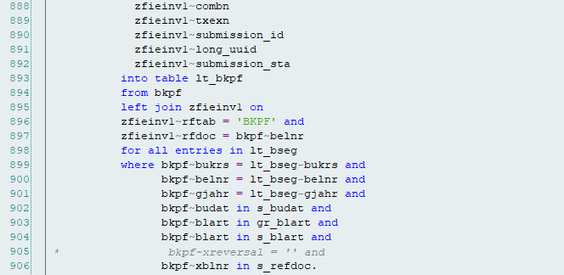
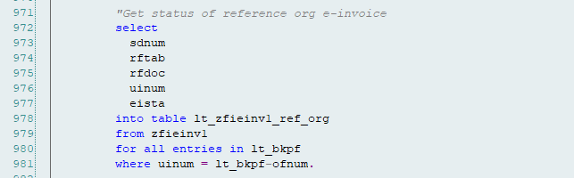
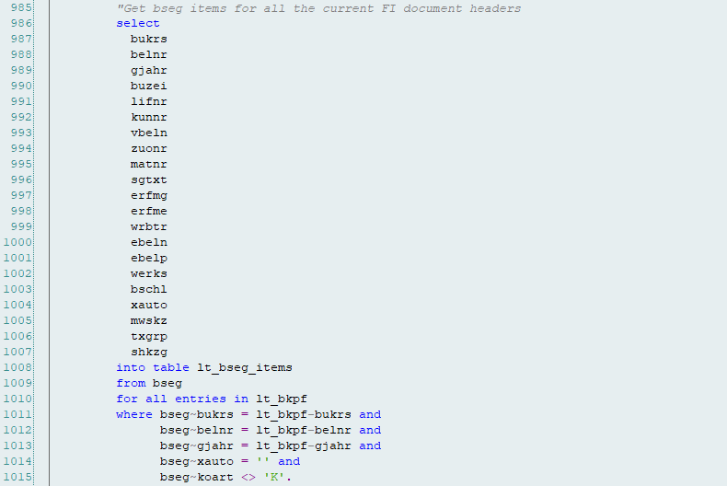
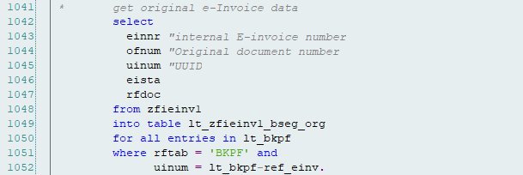
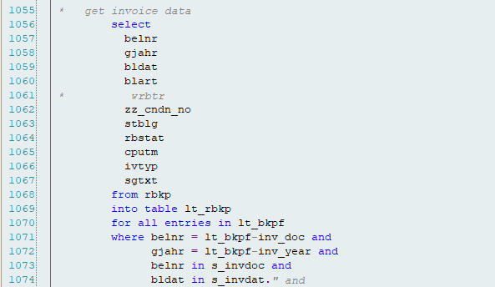
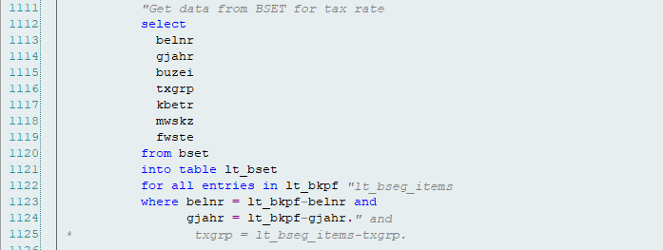
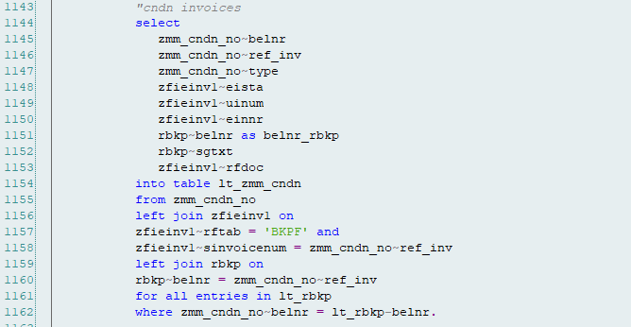
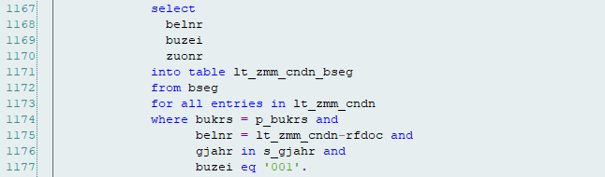
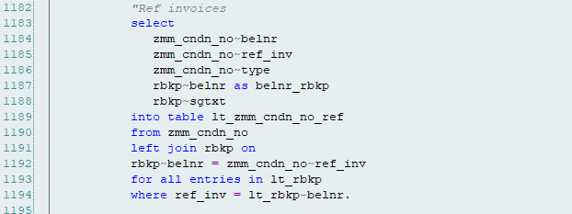
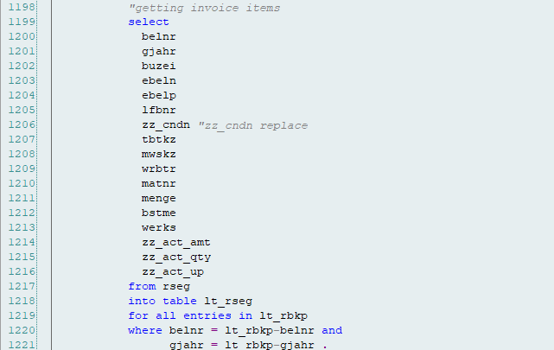
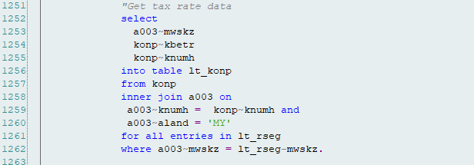
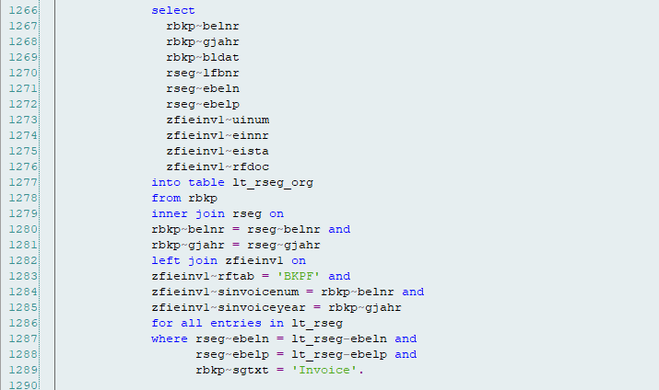
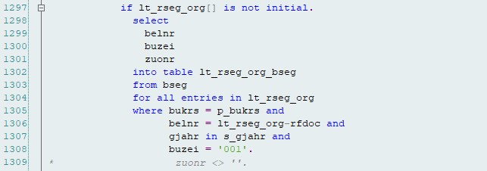
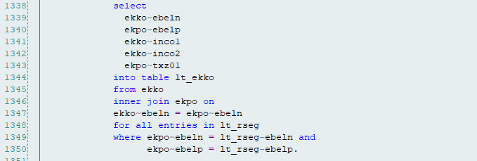
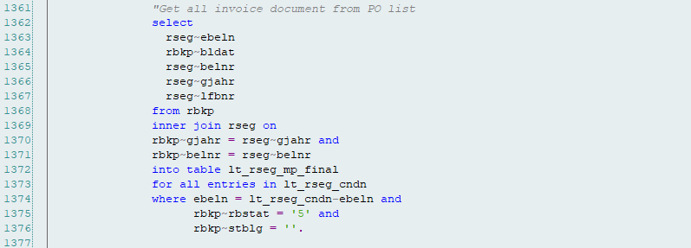
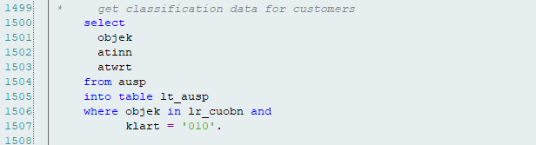

2.4.2.2 Select data for Customer
Method : GET_CUST_DATA
Code line : from 3005 to 5993.
Select data from BKPF, BSEG, ZFIEINV1, ZMM_CNDN_NO, RBKP, BSET, RSEG, KONP, EKKO, MARC, KNA1, VBPA, ADR6, ADRC.

- Billing without FI Document = No => p_bill = blank.
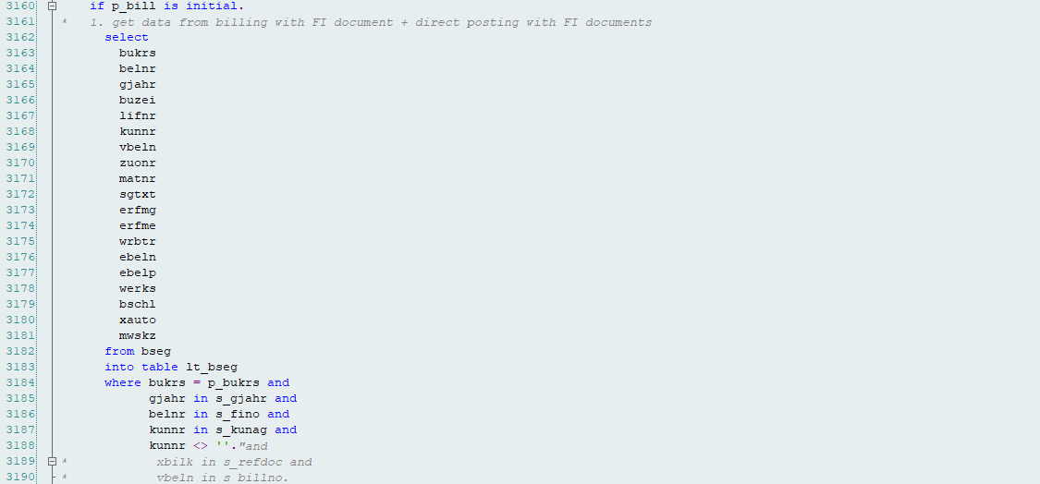
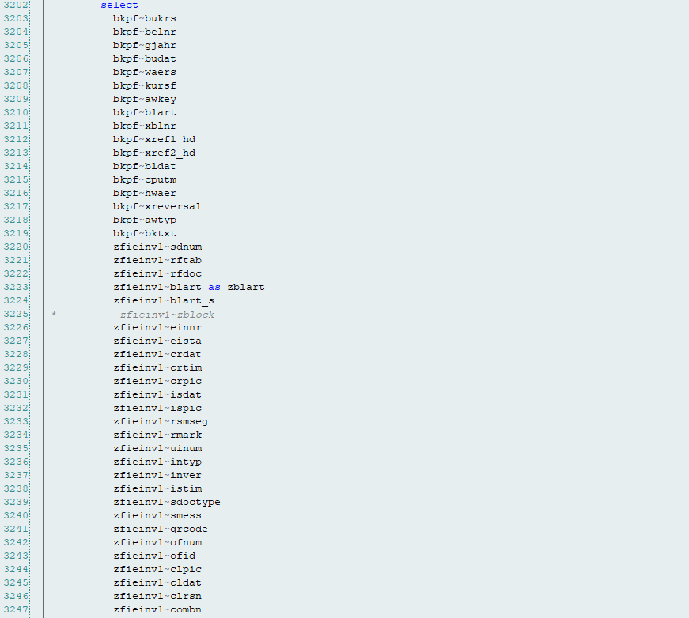
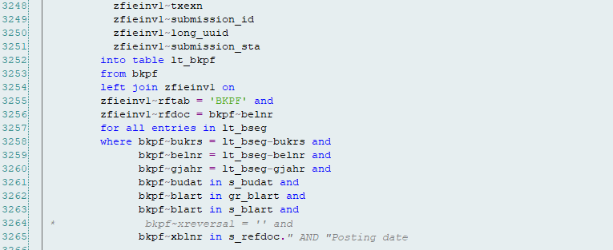
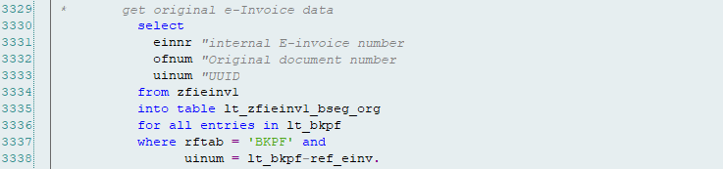
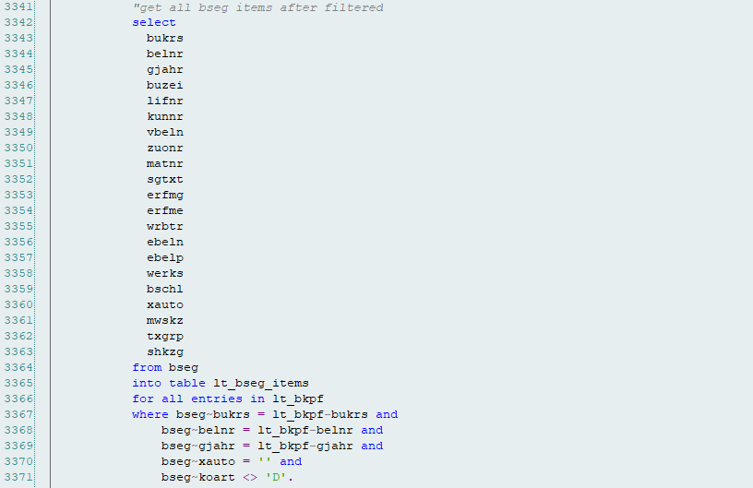
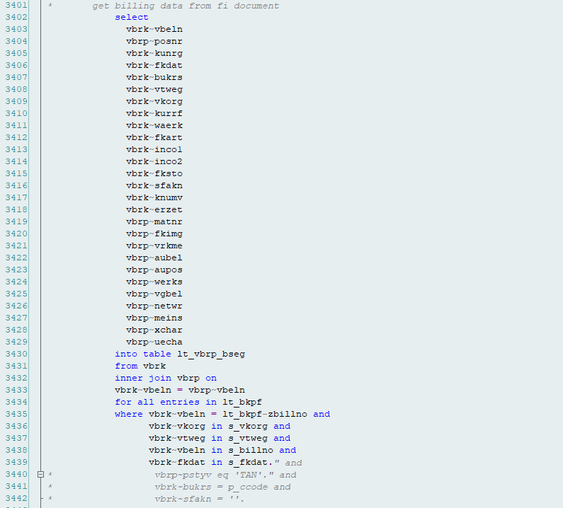
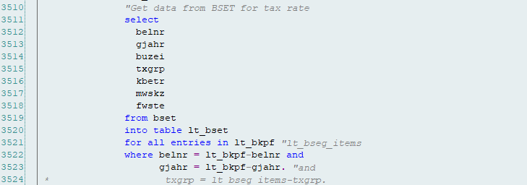
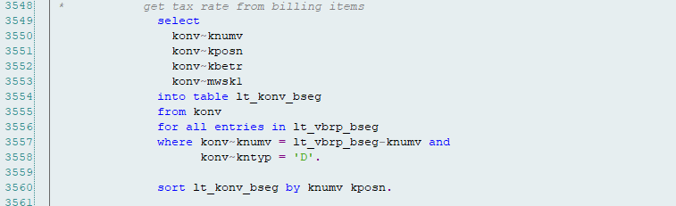
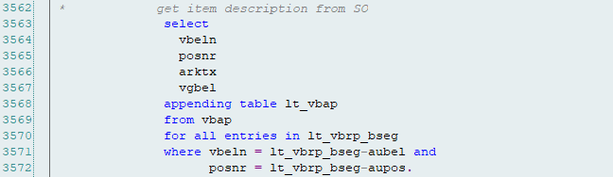
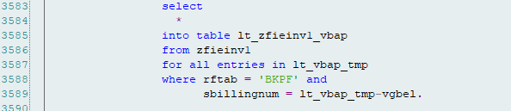
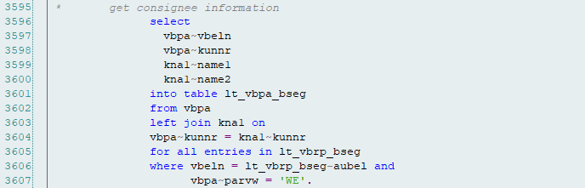

- Billing without FI Document = True => p_bill = X.
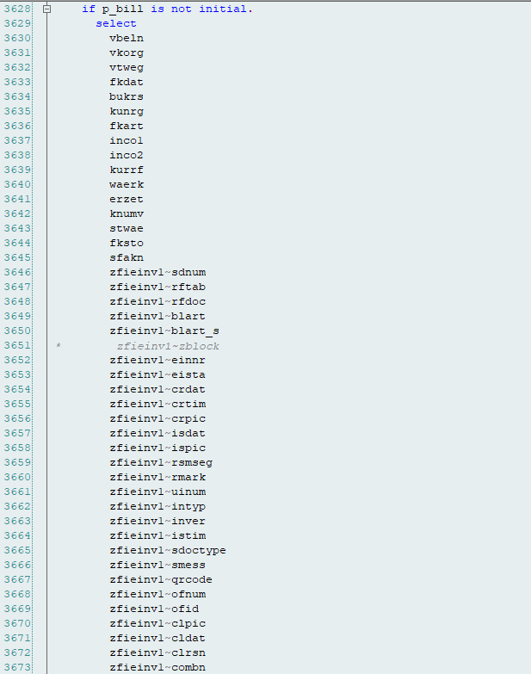
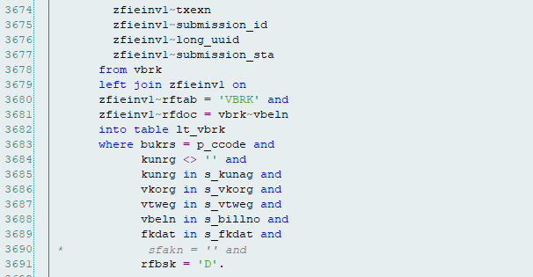
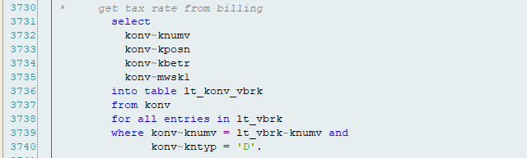
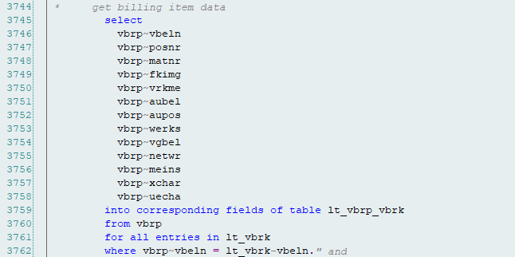
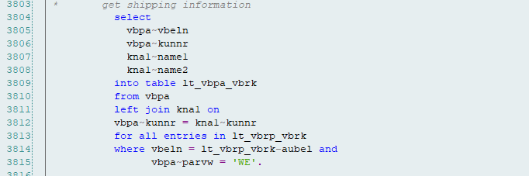
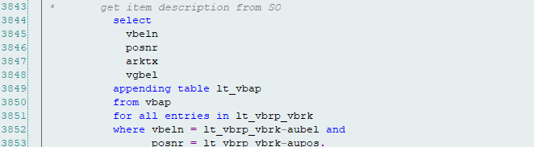
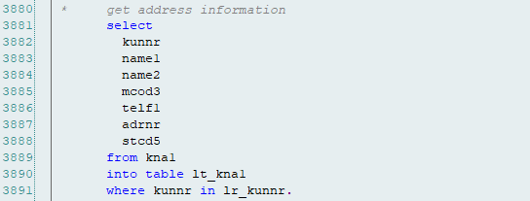
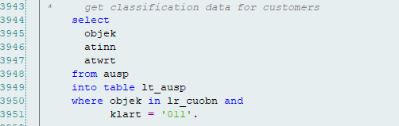

Technical Unit Test
The unit test document is attached below.
N/A

Test data:
N/A

